Surface Goaf Hole Drainage Trials
At Illawarra Coal
Tim Meyer
ABSTRACT: Surface goaf gas extraction methods are successfully applied at a number of Australian and overseas underground coal mines. BHPB Illawarra Coal has recently undertaken a trial program to determine the effectiveness of surface goaf wells to reduce gas concentrations within the longwall ventilation circuit, and minimise gas related production delays. Three trial wells have been completed within the Bulli Seam operations. Considerable production variation between the three wells was recorded. A goaf gas reservoir model is discussed which describes a sequence of permeability changes within the different goaf strata, dictated by stress changes associated with caving, then recompaction. A requirement for further work is identified to improve understanding on the 3-D properties of the goaf in terms of permeability variations and pressure distributions. An overview of the surface goaf extraction trials including descriptions of the gas plants and well production results is provided.

BACKGROUND
Goaf gas typically originates within the seams and strata surrounding the extracted working seam. Gas is liberated from these seams/strata by the processes of de-stressing and comminution associated with longwall caving. The liberated gases migrate along newly created fractures into the goaf voids. Goaf gas drainage holes attempt to remove these gases from the goaf before they can flood into the face and return circuits. Goaf drainage is therefore considered a post-drainage technique.

Surface goaf gas extraction methods are successfully applied at a number of Australian and overseas underground coal mines. Review of the techniques used indicates a wide variation in the design of the gas extraction plants, and the spacing and location of the goaf gas wells. Factors that influence these parameters include the specific gas emission, gas composition, longwall panel width and mining rate, depth of cover and goafing characteristics.

BHPB Illawarra Coal has recently undertaken a series of trials of goaf gas extraction wells drilled from surface. The aim has been to determine the effectiveness of these wells in reducing the gas quantity reporting to the longwall face and returns, and in doing so to reduce the number and severity of gas related production delays. To date, there have been three trial wells – two at West Cliff Colliery and one at Appin Colliery.

The general scope of the trial project was as follows:

- Drill and complete three wells, cased with cemented 250 mm ID thick-walled steel pipe to below the Bulgo Sandstone formation, with uncemented 200 mm ID slotted casing installed to a short distance above the working seam
- The procurement (lease), installation and commissioning of two goaf gas extraction plants
- Continuous operation of the plants for an extended period of time, defined by the period for which the plants are noticeably beneficial to underground conditions
- Plugging and abandonment of the wells upon completion of gas extraction
- Review of the data to determine the effectiveness of the technology
An overview of the surface goaf extraction trials including descriptions of the gas plants and well production results is presented. A description of the likely mechanism for gas release and migration into the goaf space is provided.

GAS RESERVOIR CHARACTERISTICS
Some of the main considerations in the design and implementation of a surface goaf well program are:

- the reservoir properties of the gas bearing formations and seams lying above or below the extracted seam section,
- the effect that extraction process has on these reservoirs; primarily pressure and permeability changes,
- the characteristics of the goaf and surrounding strata in terms of their resistance to the flow of this gas from entering the goaf volume.

Gas reservoir properties are provided in this section. Hypothetical descriptions on the likely effect that coal extraction has on these reservoirs, and the flow characteristics of the goaf zones, are provided later on in the generalised goaf gas reservoir model.

A typical stratigraphic profile for the West Cliff goaf well trial area is given in Table 1, along with estimates of the potential contribution from each of the major gas bearing strata to the specific gas emission associated with production (Moreby, 2005). Table 1 illustrates that potentially up to 45 m³ of gas is liberated for every tonne of coal extracted. Management of this high specific gas emission has to date been by a combination of techniques including bleeder airways drawing this gas towards the tailgate and inbye end of the goaf, capture of floor seam gas emissions by cross-measure drilled boreholes, as well as goaf drainage holes drilled from adjacent roadways. This trial is the first significant attempt by BHPB-IC to drain goaf gases from surface drilled holes.

No accurate measurements of the roof stratum gas contents exist. This is primarily due to the fact that this gas exists as free gas (or in solution with water) within the pores of the sandstone matrix. Any attempt to recover core from this rock inevitably results in the core becoming de-pressurised, and hence losing a large part of this gas before it can be captured for measurement.

Table 1 Typical stratigraphic sequence with potential gas emission quantities
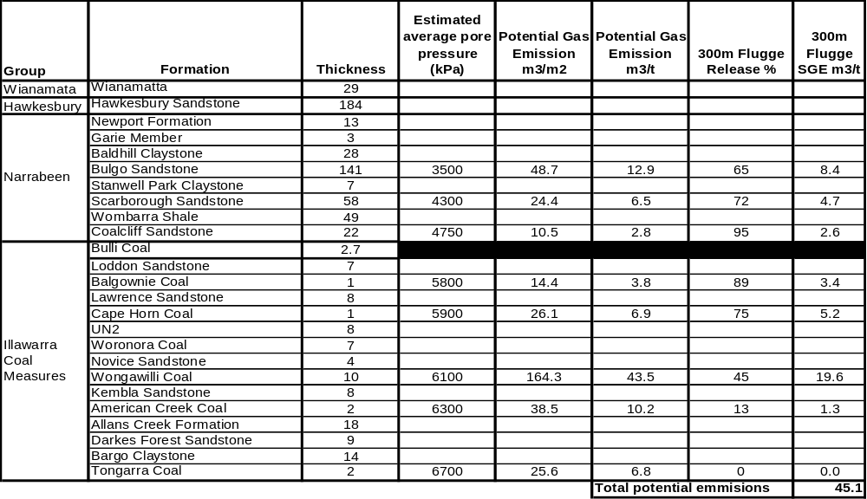

In determining the potential contribution from the roof stratum presented in Table 1, assumptions were made that the gas is only contained in the lower sandstone bearing formations (Bulgo, Scarborough and Coalcliff), that the gas occurred as free gas at pressure, and that the unsaturated porosity of the stratum was 1 %. The potential emission from each stratum was then adjusted by the Flugge method to account for the likely release based on panel width and vertical separation to the working seam.

Potential floor seam gas emissions listed in Table 1 were calculated based on desorption from 100 % CH4 fully saturated gas content values (around 14 m³/t) to residual values based on hydrostatic pressure conditions existing below the extracted section. These amounts were then adjusted by the Flugge method to account for panel width and depth below the extracted seam.

Actual estimates of cumulative specific gas emissions for Appin Longwall panels 402 to 405 are presented in Figure 1, (Self 2004). SGE is calculated based on totalising gas reporting to the ventilation circuit (tailgate and bleed), gas captured in cross-measure drilled holes into the floor seams (which tend to only flow after the longwall has passed) and goaf drainage holes, and dividing by the tonnes produced from the longwall panel. The graph illustrates that specific gas emissions of between 35-40 m³/t were measured for these four panels. This compares reasonably closely to the predicted quantities indicated in Table 1.

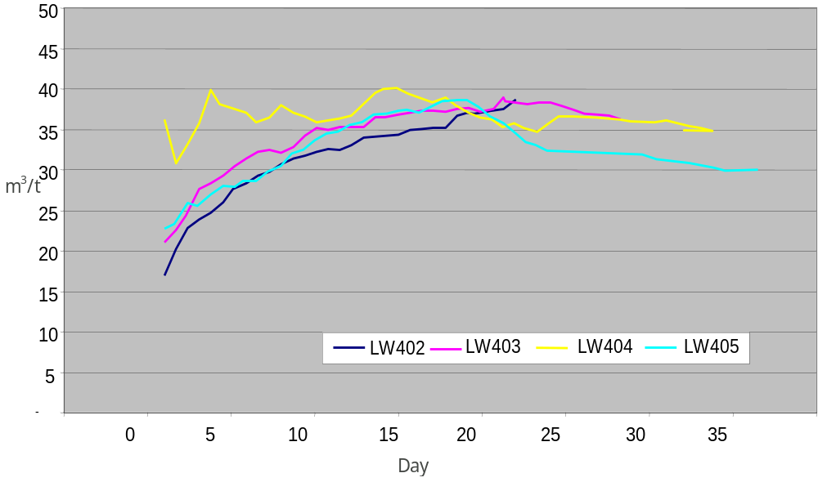Fig. 1 - Cumulative Specific Gas Emission - Appin Longwall Panels 402–405

WELL DESIGNS
A generalised well design typical of all three trial wells is shown in Figure 2. The main design features are as follows:

- 14” surface casing installed and grouted to around 50 metres below GL.
- 10”, thick walled, welded line pipe grouted to at least five metres below the floor of the Bulgo sandstone formation
- 8” slotted casing installed without rigid connection (floating) to between 5 and 35 metres above Bulli Seam roof (50 mm circular slots at a density of ten per six metre length)
Actual details of installed wells are in Table 2.

Figures 3 and 4 show the location of the trial wells at West Cliff Colliery and Appin Colliery, respectively.
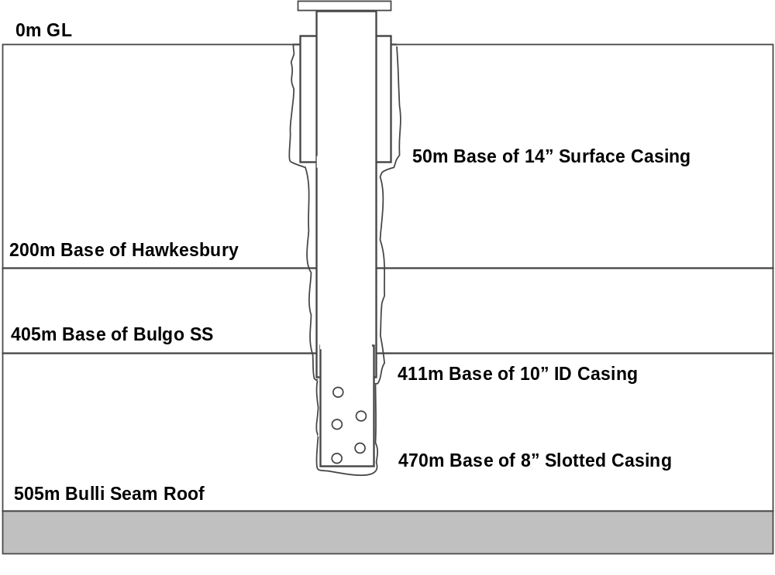
Fig. 2 - Typical trial surface goaf well

Table 2 - Details of installed goaf drainage wells

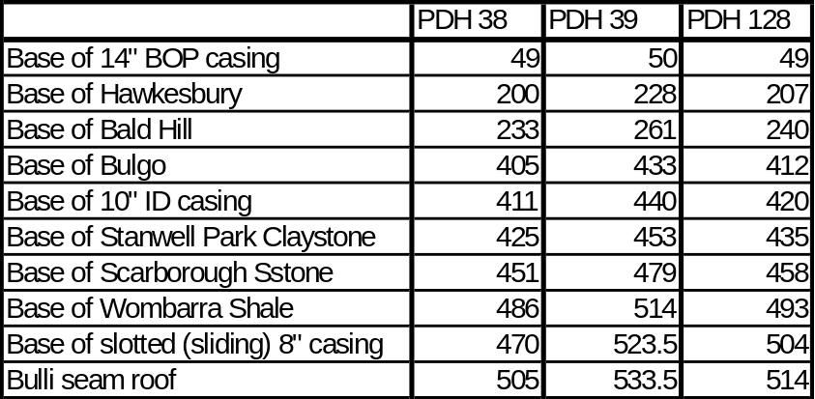

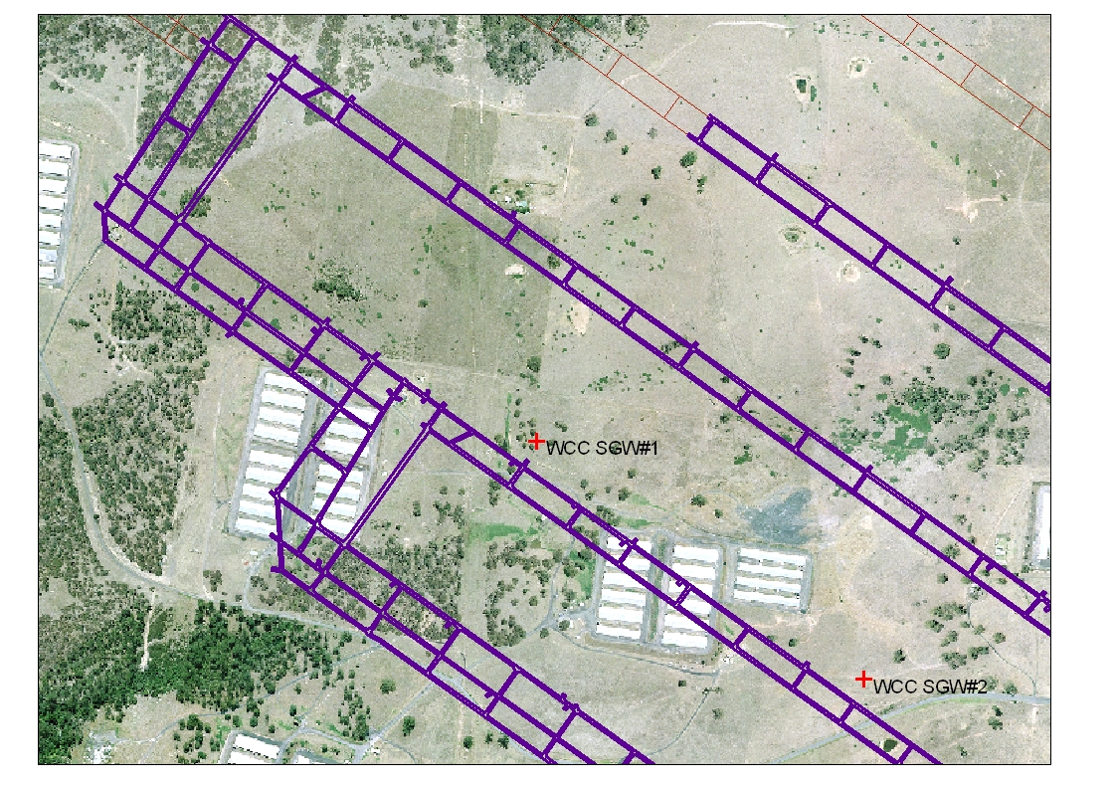 Fig. 3 - Aerial view showing location of WCC SGW’s Nos 1 & 2

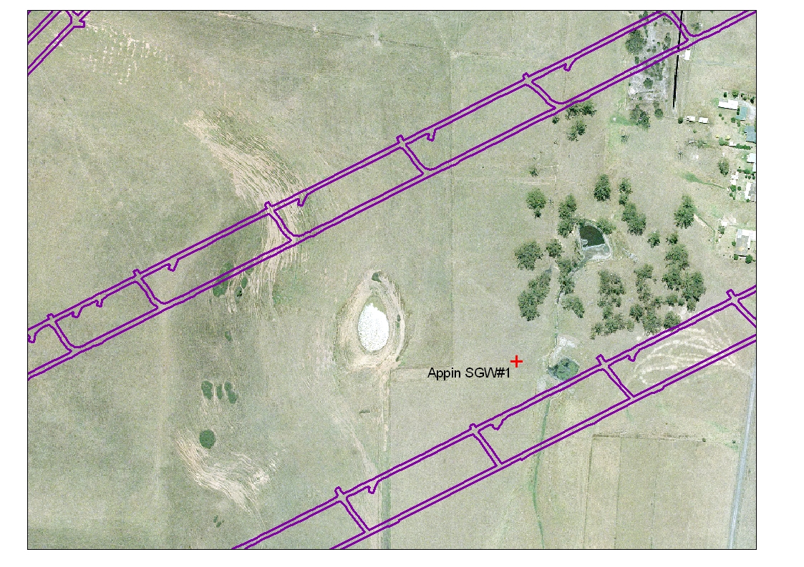

Fig. 4 - Aerial view showing location of Appin SGW No 1

GOAF GAS EXTRACTION PLANT No 1 DESCRIPTION

Overview
Goaf gas extraction plant No 1 is a modified unit leased from Anglo Coal Australia, originally designed for operation at the Dartbrook Mine, Muswellbrook NSW.

The plant consists of a Howden centrifugal fan, 1.38 m in diameter, driven by a 150 kW 4-pole electric motor. The motor and fan are housed in an acoustic enclosure. An 110 kW variable voltage – variable frequency (VVVF) drive is used to power the fan motor. The under-rating of the drive (compared to the motor) is possible due to the lower flow rate expected from the WCC well. A 150 kVA 415 V genset supplies power to the goaf extraction plant and associated control systems. Extracted gas is exhausted to atmosphere through a vent stack approximately 8 metres above ground level.

The plant, as originally designed, has the capacity to extract in excess of 2000 litres per second with a nominal suction pressure of 10 kPa. Dartbrook has previously achieved these flows by connecting up to three individual wells to a single gas plant. Due to the fact that only single wells will be connected to the plant during the BHPB-IC trials, and considering flow restrictions caused by the diameter and length of the casing installed into the WCC goaf well, the plant is expected to extract between 500 and 1000 lps per well.

A comprehensive range of electronic sensors are used to monitor important operating parameters of the plant. The outputs from these sensors are connected to a TROLEX Sensor Controller module, which allows user-defined set-points to be programmed. The TROLEX Sensor Controller has four relay trip outputs, three of which are connected to latch relays which cut-off the VVVF drive output, the fourth is connected to the genset fuel solenoid, therefore cutting power to the entire gas plant. The fan speed is manually adjusted by a potentiometer connected to the VVVF drive.

The plant is connected to the well via a ten metre long 14” victaulic pipe range. At the wellhead is a 250 mm ANSI 300 lb gate valve, used as the main isolation valve. Above this are a 90 degree elbow and 10” butterfly valve, then an adapter to the 14 in victaulic pipe line. The gas flow passes through a flow measurement venturi device and the flame arrestor before entering the intake of the fan. The full plant and site setup for West Cliff Surface Goaf Well No1 is shown in Figure 5.
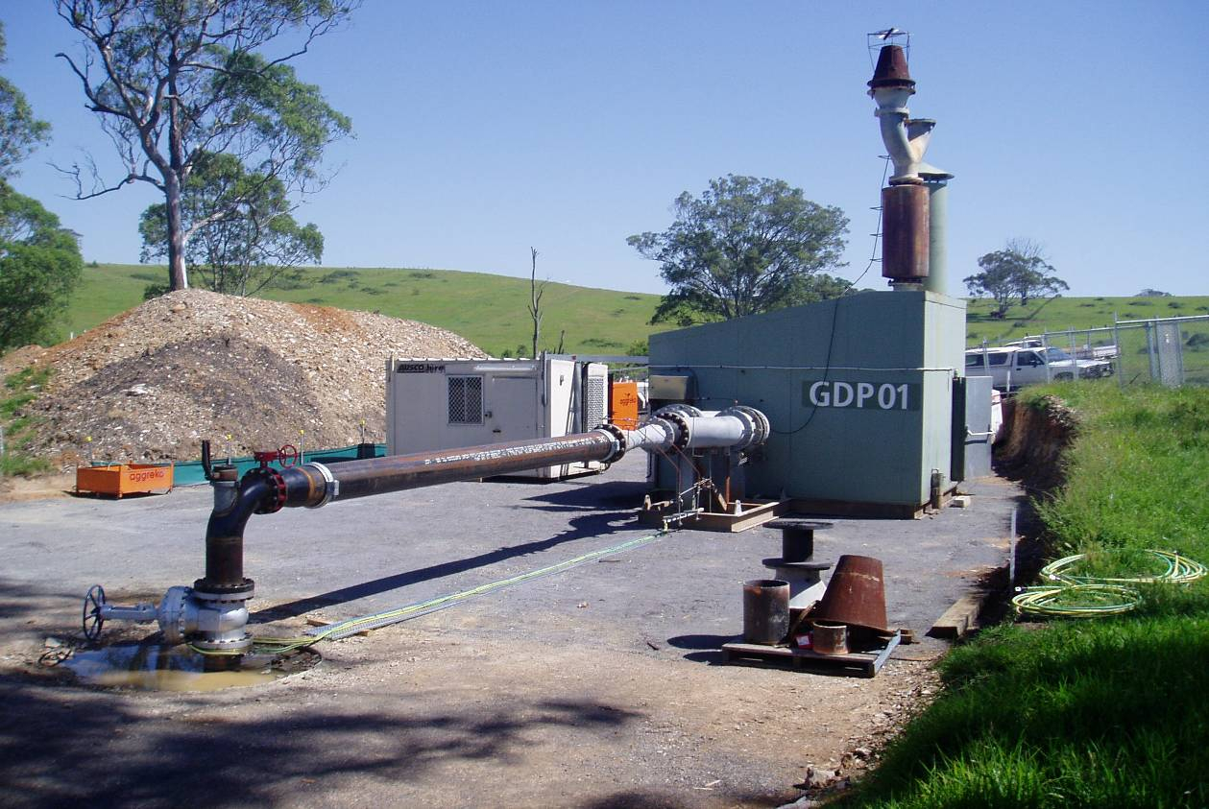

Fig. 5 - Goaf gas extraction plant No 1

Plume Ignition Protection
Lightning presents the greatest risk of ignition of the vented gas plume. A design for lightning protection, in compliance with Standard NZS/AS 1768 was commissioned. This work highlighted that in order to protect the gas plant infrastructure from a direct strike, 4 x 15 metre high lightning masts would be required, spaced around the gas plant and wellhead, with each mast individually grounded by an array of four earthing electrodes grouted in to a depth of five metres. In order to prevent lightning from entering the probable gas plume envelope, the lightning masts would need to be increased to over 25 metres in height. On reflection that the design standards do not prevent the possibility of a direct strike, but merely reduce it by a factor of 95 %, it was decided that a better form of lightning ignition prevention control was to implement a procedure which required the plant to be shut down whilst storm activity was within a 10 km radius of the gas plant.

In addition to the above procedure, the gas plant has been fitted with other devices to minimise the hazards associated with gas plume ignition. A heat detection “pyro-tube” was fitted above the vent stack. This tube reacts to heat from plume ignition, causing the pressure in the tube to substantially rise. This pressure rise is detected by a mechanical regulating valve fitted onto a large bottle of compressed CO₂. The regulating valve fully opens, dumping CO₂ into the vent stack. At the same stage, a pressure sensor detects activation and sends an electrical signal to operate a flag relay, which in turn trips the VVVF drive. Flame arrestors were fitted to the vent stack and to the inlet side of the gas plant, situated between the fan and the wellhead.

GOAF GAS EXTRACTION PLANT No 2 DESCRIPTION

Overview
Goaf Gas Extraction Plant No 2 is based on a Nash CL3002 liquid ring vacuum. The pump is powered by a constant speed 110 kW four pole electric motor, connected by a V-belt drive system that reduces the pump speed to about 350 rev/min. At this speed the plant has capacity to draw in excess of 1200 litres per second at suction pressures up to 60 kPa. The motor, V belts, pump, and control panel are mounted on a common skid. A 375 kVA genset is required to power the DOL start 110 kW motor, as well as other site electrical requirements.

Control of the plant is provided by a small PLC unit. The PLC monitors the state of a compressed air automatic valve shut-off system, gas composition monitoring equipment and the liquid ring pump seal water supply system. Signals from all three systems must be healthy for the PLC to allow operation of the vacuum pump.

The compressed air automatic valve shut-off system is based on two pneumatically operated butterfly valves, one positioned at the wellhead, the other on the discharge line. These valves, configured to open when energised, will automatically close if the gas plant is tripped or manually stopped. A small air compressor supplies compressed air through a solenoid activated 3/2 way valve, configured to dump the air pressure if de-energised. The PLC monitors the air reservoir pressure, to ensure sufficient pressure is available to open the valves.

Gas composition monitoring is achieved by Trolex CH₄ and O₂ sensors, feeding into a Trolex Sensor Controller unit. The relay output from this unit is connected into the PLC input to register gas out-of-range conditions and trigger a shut-down of the vacuum pump.

Two detonation arrestors are installed in parallel after the main isolation valve as protection against flashbacks if other protection systems fail. Each of the arrestors can be individually isolated by manually closing its inlet and outlet valves and can then be removed for cleaning the elements. A non-return valve is installed after the arrestors to provide additional protection against backflow down the borehole. A 10 in diameter steel Victaulic pipe is run between the wellhead and the vacuum plant. A venturi flow measurement device is fitted near the plant to provide flow rate measurements. The plant, inlet pipework and flow separator can be seen in Figure 6.

The overall gas flow rate is varied by recirculating a portion of the gas from the discharge of the separator back to the inlet of the vacuum pump, by manual operation of a butterfly valve on a recirculation pipe. Because the gas is cooled by the flow of seal water the entire throughput of the pump can be recirculated if necessary without overheating.

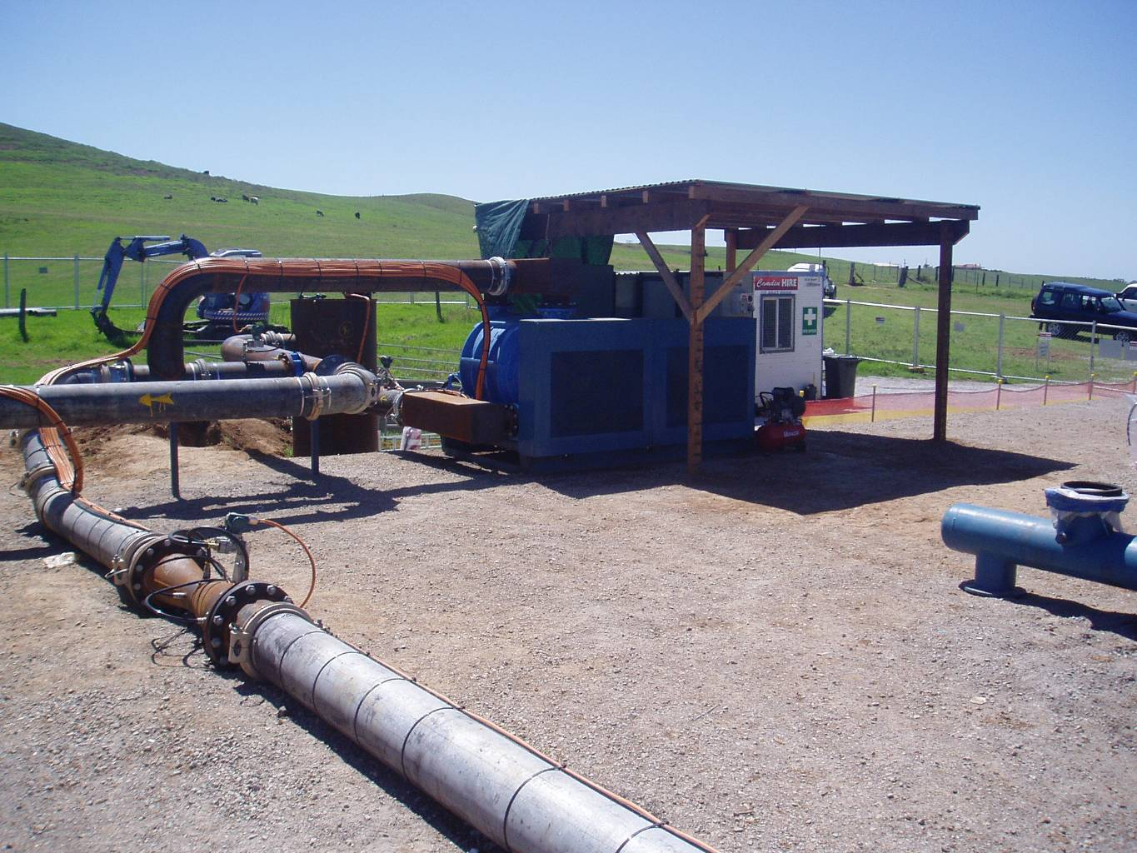

Fig. 6 - Gas extraction plant No 2 – plant, inlet pipework and flow separator

ENCLOSED GAS FLARE UNITS
An important aspect of the Goaf well Trial was to investigate the applicability of enclosed flares as a means of disposal of extracted gas. Not only is there considerable environmental benefits in flaring the gas as compared to free venting to atmosphere, there was serious concern that the odour of the exhausted gas would be detectable by local residents in close proximity to the selected trial sites. This close proximity also precluded open flaring options, from a visual impact perspective, hence the need to use enclosed flares.

Two enclosed flare units were hired from Landfill Management Services Pty Ltd (LMS). Refer Figure 7. As their name suggests, LMS specialise in enclosed flare units for the flaring of landfill gas. The flare units are essentially a refractory lined stainless steel stack approximately eight metres high and 1.4 metres in diameter. A small centrifugal fan in each unit is capable of drawing up to 1000 m³/hr of gas at around 15 kPa suction pressures. As gas was being supplied at pressure by the goaf plants to the flare units, these flare fan units were disabled.

The supplied gas is injected into the base of the stack through a series of burners. The combusting gas/air mixture rises up the enclosed stack, drawing air in through a series of vanes at the base of the stack.

Numerous monitoring and safety devices are fitted to each flare unit, including:

- Draegar Polytron CH4 sensor
- Stack flame detector (UV light)
- Flashback temperature sensor

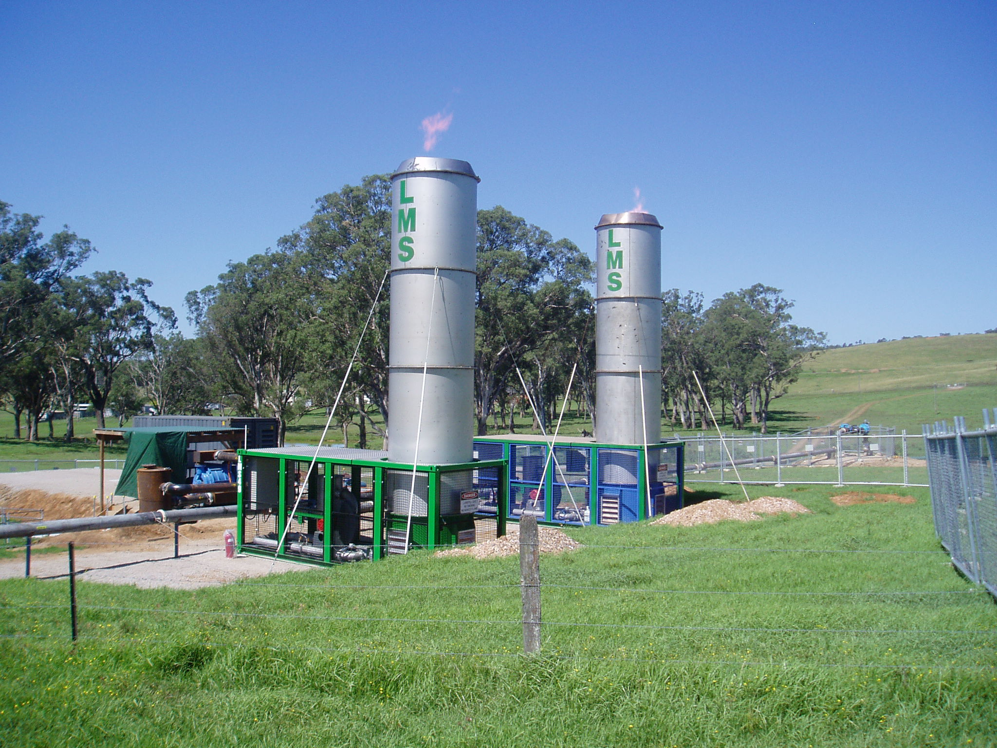

Fig. 7 - LMS Enclosed flare stacks operating at Appin SGW No 1

Output from these devices is monitored by a small PLC unit, which will trip a solenoid activated shutoff valve if threshold levels are reached. Additional protection from flashback is provided by a flame arrestor in the discharge pipeline.

OPERATING PROCEDURES AND MONITORING
In light of the short-term duration of the trial program (approximately 6 months), a decision was made not to invest in automation and telemetry systems that would enable remote control and monitoring of the plants. Instead, the gas plants were supervised on a continuous 24/7 basis. Similar monitoring regimes had been used for monitoring of Bulgo drainage holes on the Appin mine lease.

A set of “Normal Operating Procedures” was developed which prescribed the sequence of actions required for plant start-up and shut-down. In addition, a series of specific operating procedures was developed for instances when operating parameters reach respective trigger levels, as defined in the TARP. These are termed “abnormal operating procedures” because they were only applied when particular sensor readings fell out of normal range. Depending on which sensor measurement reached a trigger level, a corresponding procedure sheet was to be referenced to specify appropriate procedures to be followed by the site monitor.

The monitors’ duties included taking regular readings of all the sensors and monitors around the gas plant, and recording these onto a paper shift monitoring report, as well as entering this data into an Excel spreadsheet for daily electronic distribution to relevant personnel.

WEST CLIFF COLLIERY SGW NO1 RESULTS

Initial Connection
The first trial well, WCC SGW No1 was situated above West Cliff Longwall 31, approximately 715 metres outbye from the face installation road. The well was situated 40 metres from the tailgate drive. Refer Figure 3.

The longwall progressed under SGW No 1 on 10/12/05. No sign of connection between the goaf and the well was seen until the11/12/05, when the longwall had advanced approximately ten metres past the well. At this point, the pressure at the well head dropped over a period of a few hours to around -75 kPa. This high suction pressure was due to the column of water which was originally in the well slowly emptying into newly connected goaf voids. This high vacuum pressure was sustained for around 24 hours, indicating only a very slight leakage path, after which it gradually reduced back to around 0 kPa over a 12 hour period.

The wellhead pressure was constant at around 0 kPa for the next 48 hours, then on the morning of the 16/12/05, a slight positive pressure was measured. At this stage the longwall had progressed to approximately 50 metres past the well. A plot of wellhead pressure versus time for this initial connection period is shown in Figure 8.

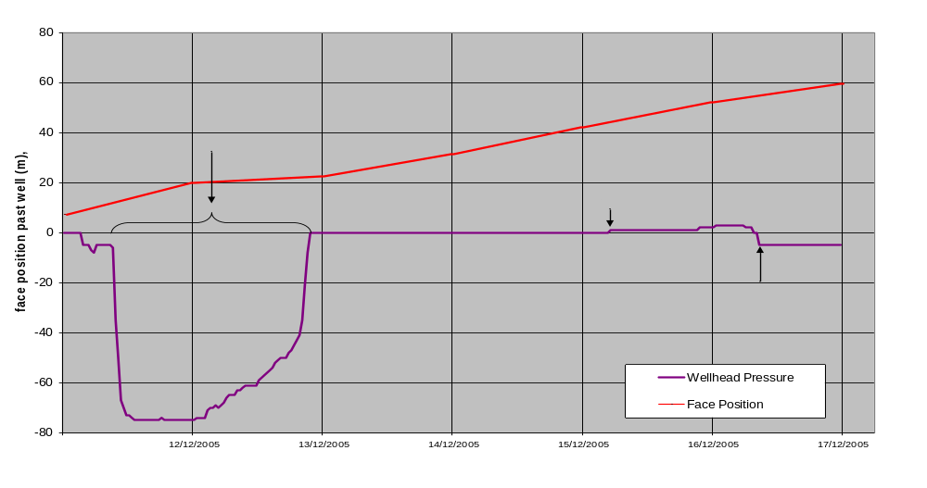
Fig. 8 - Plot of wellhead pressure and longwall position relative to well

WCC SGW No 1 – Production History
The goaf gas extraction plant was run continuously from 16/12/05 to 6/3/06. A full plot of plant suction pressure, measured gas flow rate and face position relative to the well is shown in Figure 9.

Initial gas flow rates of around 600 lps were achieved with a suction pressure of 7 kPa. After an initial “running in” period of a few days the motor frequency was turned to 70 Hz, producing the maximum allowable fan speed of 2100rev/min. Suction pressure increased to 9 kPa and a flow increase to 700 lps was achieved. At this stage the longwall was approximately 110 metres past the well.

On the 27/12/05, with the wall around 150 metres past the well, gas flow rate began to climb steadily over a three day period, peaking at a maximum of 1000 lps, but then began to decline. Coinciding with this peak was a water release event, leading to a fine mist emanating from the stack. It is probable that these events were caused by casing breach in the Bulgo Formation, with an associated inflow of pressurised gas and water. Following this spike in gas flow and water event, the gas flow gradually dropped over a ten day period to around 500 lps. Following this, gas flow averaged 480 lps for the remainder of the plant operating time, up to 6/3/06.

The main indicator of effectiveness for a goaf well is the reduction in gas reporting to the ventilation circuit. Figure 10 shows the gas level in the tailgate immediately prior and after commencement of the goaf gas extraction plant. Within 40 minutes the tailgate methane concentration had reduced by 0.8 %. A more detailed analysis of the tailgate and bleeder circuit gas levels over the ten week period for which the plant was operational, indicates that the effect on tailgate gas percentage diminishes with distance. For instance, Figure 11 presents tailgate gas levels during a shut-in of the well for a brief three hour period when the longwall was 270 metres past the well. An obvious increase in tailgate gas level of approximately 0.25 % is evident coinciding with the shut-in. This rise is negated within 90 minutes of re-starting the gas plant.

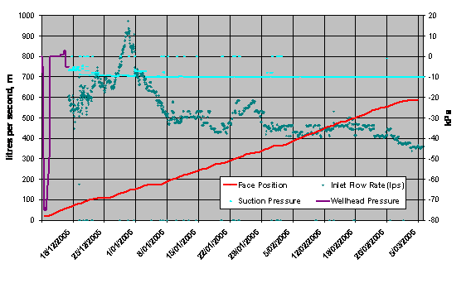
Fig. 9 - Production history for WCC SGW No1

Free Venting
During scheduled maintenance shutdowns of the plant, it was observed that the well would continue to free vent gas at considerable rates (in excess of 400 lps), and that shutting the main wellhead valve caused the wellhead pressure to rise in excess of 70 kPa. Figure 12 shows the free venting flow rate and shut-in pressure for the well during a typical shut-down.

Whilst providing an insight into the characteristics of the gas reservoir above the goaf, it also highlights that the well connection to the goaf was now substantially restricted as demonstrated by the high pressure build-up in the well casing. Notwithstanding this poor connection, shutting in the well impacted on the longwall gas makes as noted by significant increases in tailgate gas levels coinciding with the shut in periods (between 0.7 % and 0.2 %).

Based on these high free venting flows and the continued positive impact on tailgate gas levels, a decision was made to continue free venting from WCC SGW No 1 after the plant had been relocated. On the 6/3/06, the plant
was shut down and mobilised to WCC SGW No 2 site. A free venting facility was established with the inclusion of a pneumatically operated shut-off valve and detonation flame arrestor. An eight metre high 10 in diameter vent stack was situated approximately ten metres from the wellhead. A compressed air line was positioned above the vent stack in case of ignition – the tube would burn, releasing the compressed air and the pneumatic shut-off valve would close. Trolex CH₄ and O₂ sensors were fitted to monitor gas composition. Free venting was maintained for the period 10/3/06 till 1/5/06, during which the average gas flow from the well was in excess of 320 lps, at a gas purity of around 90 % methane.

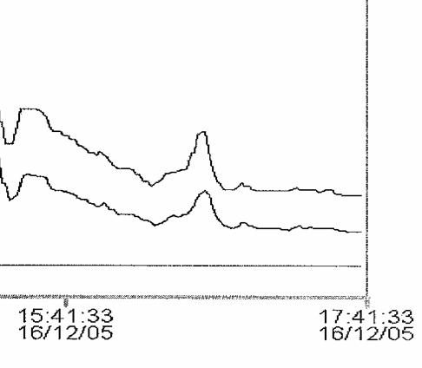

Fig. 10 - WCC SGW No 1 reduction in tailgate gas on plant start-up

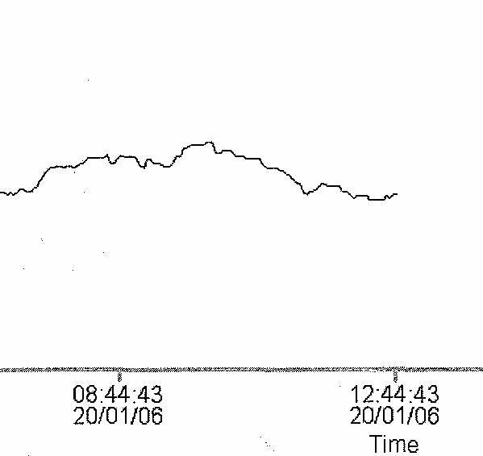
Goaf well shut in
Goaf well re-opened
0.25%

Fig. 11 - WCC SGW No1 Effect of plant off/on at 270 metres in bye of longwall
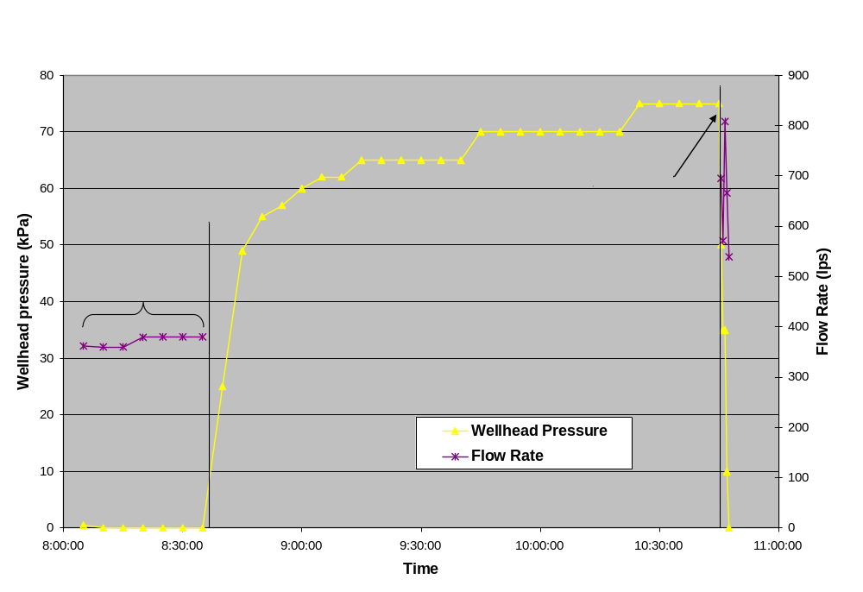
Fig. 12 - Free vent flow rate and shut-in pressure

WCC SGW No1 Extracted Gas Composition History
Regular bag samples were collected from the WCC SGW No1 flow since extraction commenced on 16/12/05. Figure 13 shows gas composition history from well start-up to mid April. Evident in the graph is the fact that methane concentration remained relatively steady at around 88 %, and ethane concentration initially started just below 3 % and gradually rose to just below 4 %. An important indicator of gas origin is the ratio of ethane to methane. The floor seams have very low ethane concentrations, whilst the major roof strata reservoirs (Bulgo and Scarborough sandstones) have been estimated to have 2.9 % and 7.5 % respectively (dotted lines on graph).
Figure 13 shows that the ethane to methane ratio for the measured period was initially 3 % and over the measured period rose to just over 4 %. This clearly suggests that a major component of the extracted gas originated in the roof strata. There is, however a range of possible component contributions from the roof strata and floor seams which could generate this ethane to methane ratio. For instance, this ratio results from mixing approximately 50 % floor seam gas with 50% Scarborough gas with no Bulgo gas, and also from a mix containing mostly Bulgo gas with smaller amounts of Scarborough and or floor seam gas. Issues with CO₂ coming out of solution from groundwater in the roof strata preclude using CO₂ as an indicator of the seam gas component. Investigations are currently underway to determine if more elaborate finger-printing techniques might provide a better understanding on the component contributions from the individual roof strata and floor seams.
Tailgate Gas Composition Monitoring
During the operating period of WCC SGW No1, a number of ventilation and goaf gas samples were collected and analysed. Interpretation of the composition results calculated air free is shown in Figure 14, which indicates two distinct groupings (back of goaf samples and others), (Wood 2006). Ethane/methane results from the back of goaf areas are less than 0.01 while the other samples indicate a ratio of 0.01 to 0.04.

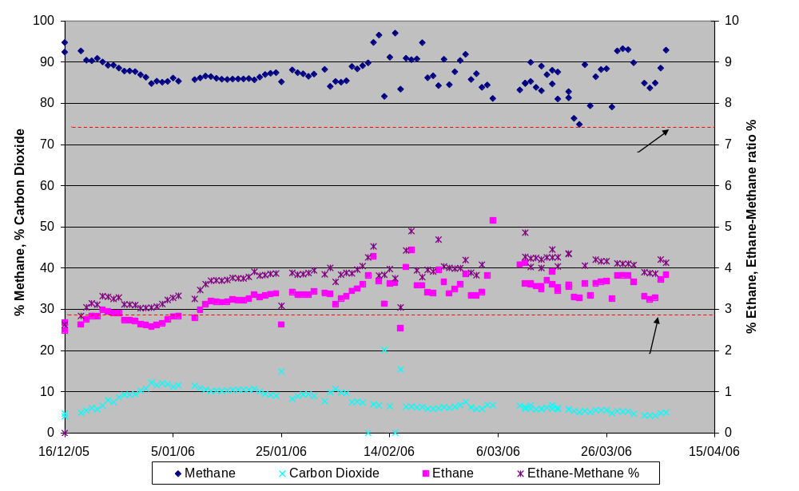

Fig. 13 - WCC SGW No1 extracted gas composition plot

Based on ethane to methane ratios for Bulgo, Scarborough and floor seams of 2.9 %, 7.4 % and 1 % respectively, the gas samples taken from the tailgate corner of the goaf and outbye in the tailgate return had signatures consistent with greater than 40 % of strata gas in the methane fraction. A maximum of 72 % of strata gas was recorded from the tailgate corner. Back of goaf samples recorded a maximum of 30 % strata gas in the methane component of the mixture. The ratio of the source components in the tailgate return remain relatively constant through the range of methane concentrations measured (Wood, 2006).

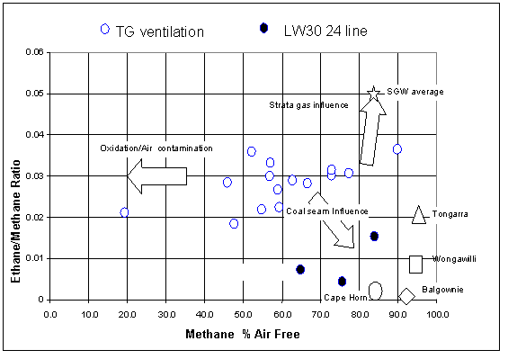
Fig. 14 - Compositional trends from underground ventilation samples

APPIN COLLIERY SGW NO1 RESULTS
Appin SGW No1 was situated above Appin Longwall 408, approximately 620 metres outbye from the face installation road. The well was situated 40 metres from the tailgate. The surface location of the well was approximately 200 metres from a cluster of houses, necessitating the use of enclosed flares to dispose of the extracted gases. Refer Figure 4.

The longwall passed under the well on 6-1-06, resulting in a similar pressure response to that measured for WCC SGW No1 (see Figure 8). Delays in commissioning the goaf plant and enclosed flares, coinciding with consecutive record weekly longwall production rates, resulted in the plant not being started until the longwall was approximately 100 metres past the goaf well.

Upon commencement of gas extraction, it became obvious that the well flow rate would be constrained by the flare units to less than 400 lps. Flow rates above this level caused considerable lengths of flame to emanate from the flare stacks, and also led to the flare units overheating. The expectation was that the two flare units would have combined capacity for 600 lps, however extreme high purity extracted goaf gas (> 90 % CH4, with an additional 2.5 % higher order hydrocarbons) reduced the capacity to this lower level.

To determine the maximum flow capacity for the well, an unconstrained flow test was undertaken on 25-1-06, when the well was 170 m behind the longwall face. This test involved running the vacuum pump system at full capacity bypassing the flare units, and diverting the gas to a vent stack. The flow rates from this trial are shown in Figure 15. Prior to the commencement of the test, the well was shut-in. The shut-in well pressure was recorded as 0 kPa. The initial peak flow rate of approximately 750 lps NTP quickly dropped to a sustained value of around 420 lps NTP with a -50 kPa suction pressure applied to the well. Interestingly, this sustained rate is only marginally higher than the demonstrated capacity of the enclosed flares.

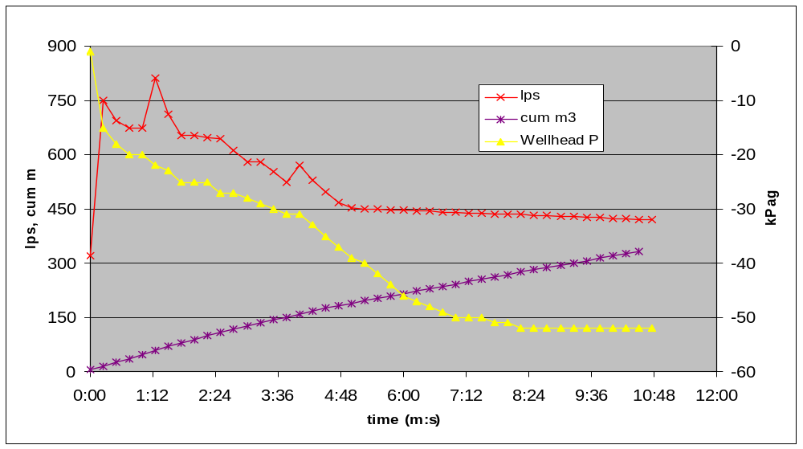

Fig. 15 - Appin SGW No 1 Unconstrained flow test on 25-1-06

At no stage during its operation did the Appin SGW No 1 well show any influence on the tailgate gas levels. In fact, gas levels measured underground at the time were significantly lower than expected, indicating an unusual reduction in the specific gas emission (SGE) for longwall extraction. Not surprisingly, this low SGE condition coincided with a record production month for the mine. It is likely that this low SGE was in part due to an extensive and sustained campaign of draining gas and fluid from the Bulgo Sandstone from a network of 6 in free flowing holes.

WEST CLIFF COLLIERY SGW#2 RESULTS

Initial Connection
WCC SGW No2 was situated above West Cliff Longwall 31, approximately 1,450 metres outbye from the face installation road. The well was situated 40 metres from the tailgate drive. Refer Figure 3. The main difference between this well and WCC SGW No 1 was the slotted casing finish depth, which for this well was just 10 metres above the Bulli Seam, whereas WCC SGW No 1 had it finish 35 metres above the Bulli Seam.

The longwall progressed under SGW No 2 on 23/3/06. Evidence of connection between the goaf and the well was first seen on 20/3/06, with a significant suction pressure of -75 kPa generated at the wellhead, indicating the well water level was dropping. This continued through till 24/3/06 when wellhead pressure changed to -2 kPa suction. On 27/3/06 the goaf plant was turned on, with the longwall approximately 25 m past the well.

WCC SGW No 2 – Production History
A full plot of plant suction pressure, measured gas flow rate and face position relative to the well is shown in Figure 16. Upon plant start-up, initial flow of approximately 800 lps was achieved with the maximum suction pressure of 9 kPa. However, at this rate oxygen levels increased to over 5 % necessitating throttling back the plant to around 550 lps, achieved by reducing suction pressure to between 5-7 kPa. Entering the second week of operation the well flow rate dropped significantly to 350 lps. This indicated a substantial loss in connectivity between the well and the open goaf zone. At this stage the wall was 90 metres outbye of the well. As the longwall progressed further away, the well flow rate continued to drop reaching a low of around 200 lps. At this flow rate the oxygen levels consistently remained below 1 %.
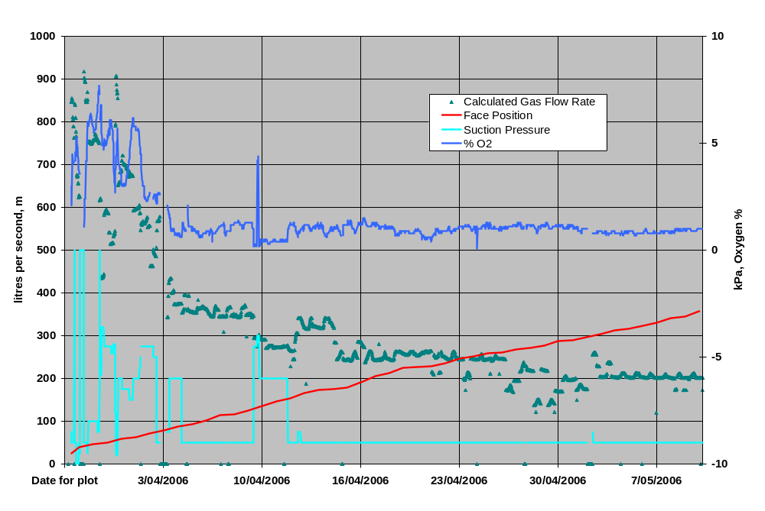
Fig. 16 - Production history for WCC SGW No 2

Figure 17 is a plot of tailgate gas levels coinciding with the initial plant start-up at 11:00 am on 27/3/06, and the subsequent 18 hour period which include a plant shut-down due to generator problems. Upon plant start-up, tailgate gas levels dropped by 0.9 % in a 1 hour period. This reduction was maintained until the generator faulted at 1:30 am. Methane concentration gradually rose 0.9 % to original levels over a 6 hour period. At 9:00 am on 28/3/06 the plant was re-started, with a rapid reduction in tailgate gas back to the lows achieved the previous day.

Several free-vent and shut-in tests have been conducted on WCC SGW No 2. Typical free-vent flow rates of less than 50 lps have been recorded, with shut-in pressures of around 2 kPa measured at the wellhead. Subsequent to the first week’s operation, no measurable effect on tailgate gas levels was noted during well shut-in tests. Based
on these observations, it is likely that a severe restriction developed between the well and the open goaf area at the end of the first week’s operation. This would most likely be either recompaction or pinching of the casing due to ground movement associated with caving. The slightly positive pressure measured during the well shut-in tests is a result of the battle between the mines’ negative ventilation pressure and the positive pressure generated by the buoyancy of methane.

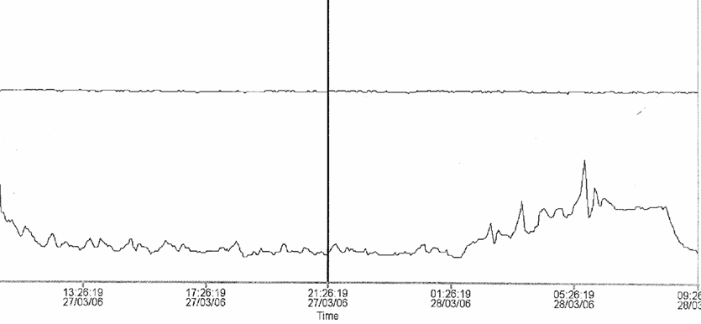

Fig. 17 - WCC SGW No 2 Reduction in tailgate gas on plant start-up
Start plant
Well shut in due to generator set failure
Well re-opened & plant started
0.9% reduction

WCC SGW No 2 Extracted Gas Composition History
Regular bag samples were collected from WCC SGW No 2 gas stream since it commenced operation on 23/3/06. Figure 18 shows gas composition history from well start-up to time of preparation, calculated on an air-free basis. Similarly to WCC SGW No 1, methane was consistently around 90 % with ethane ranging between 3-4 %. Based on the ratio of these values, it is likely that a significant component of the extracted gas originated in the roof strata sandstone formations.
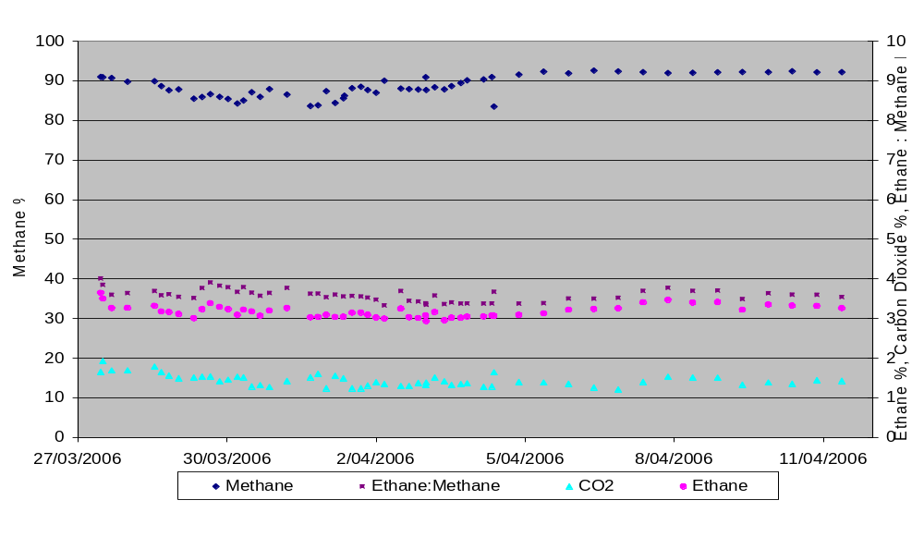
Fig. 18 - WCC SGW No 2 extracted gas composition plot

GOAF GAS RESERVOIR MODEL
In general, the effect of coal extraction on over and under-lying strata is initially to reduce the vertical stress, which typically results in failure of the roof and floor material due to high unconfined horizontal stresses. A resultant of this failure is the creation of vertical fractures which allow gas to flow from pressurised formations and seams into the goaf. Re-compaction theory has the vertical stresses rising to near original values as the longwall face progresses away from a particular location. Of importance is the extent to which recompaction might close down these vertical flow paths, thereby limiting or preventing further gas migration into the goaf.

Standard goaf compaction models declare that for competent roof material a zone of highly re-compacted, low permeability goaf is created in the central bulk of the goaf area, with lower compaction, higher permeability zones extending around the goaf fringes - behind the face and inbye adjacent to the gate roads. It is likely that vertical fractures above or below these higher compaction zones will seal up, whereas vertical fractures leading to the goaf fringes may stay open and provide gas migration pathways.

Obviously the above process is heavily influenced by the stratigraphic and geomechanical properties of the individual stratum, as well as operational factors including panel width and extraction rate. For instance, the Stanwell Park Claystones are noted for their highly plastic behaviour, and extreme low permeability. The amount of vertical fracturing induced in this formation by extraction, and the time that such fractures remain open is not known. What is known is that mining induced vertical fractures through this material are necessary for the overlying strata gas to reach the goaf.

Another significant feature of standard goafing and subsidence models is dilation occurring between bedding planes, creating horizontal gas flow paths. It is possible that these dilations play a major role in gas reaching any open vertical fractures, probably concentrated around the goaf fringes.

Figure 19 is a 2-D schematic representation of the goaf. It illustrates that the flow of gas into the goaf is pressure driven, and that the pressure differential between interburden strata layers is dependent not only on the permeability of the strata, but also on the extent and dilation of mining induced fractures. The flow of gas is dominated by joints, fractures and other highly permeable flow paths. A limiting factor to flow rate is the low matrix permeability of the host rock or seam, through which the gas must migrate before it can enter the more permeable flow paths. This is obviously influenced by the degree of mining induced fractures.

As previously discussed, recompaction will cause closure of fractures, but the goaf fringes undergo less re-compaction than the centre of the goaf. Horizontal dilation along bedding planes will assist the migration of gas towards the fringes where the gas can then flow through open vertical fractures. The driving pressure for roof gases is between 3-4 MPa, whilst the driving pressure for floor gases is up to 6 MPa. Particularly in the case for the floor gas, this pressure is sufficient to fracture interburden if unconstrained vertically.

If the re-compaction model is correct, with likely closure of vertical fractures within the claystones and shales as vertical stress increases, then the close match between the inferred “gas-in-place” estimate in Table 1 (45 m³/t) and the measured specific gas emissions reported for Appin Longwall 402-405 (35-40 m³/t) imply that the horizontal dilations play an important role in gas migration into the goaf. Without these horizontal flow paths, it is likely that less gas would reach the goaf and specific gas emissions would be less. That is, re-compaction would seal flow paths before all the potential available gas had migrated into the goaf. From Table 1, the potential specific gas emission from roof strata is 15 m³/t of coal mined, with approximately 50 % of this gas coming from the Bulgo Sandstone. For Bulgo gas to reach the goaf it must pass through the extremely low permeability and relatively plastic Stanwell Park Claystone formation and then further down, the Wombarra Shale formation. Obviously, this process is reliant on a network of vertical fractures being formed that extend upwards through these low permeability zones.

Evidence for the role that horizontal dilations provide to gas migration can be seen from the free venting characteristics of WCC SGW No 1, discussed in Section 7.2. For the free-venting period of 10-3-06 to 1-5-06, a sustained flow averaging 320 lps was achieved. During this period, well shut-in pressures of 75 kPa were often measured. These relatively high shut-in pressures indicate that the flow is pressure driven, not buoyancy driven. Gas composition analysis confirms the gas predominately originates in the roof strata. A probable conclusion is that horizontal dilations must be acting as conduits for this gas to migrate from the source rock towards the well.

Hawkesbury Sand
Bulgo Sand
Face
Goaf Well
Subsidence
4 MPa
Bulli
Wongawilli
Increasing Compaction
0 MPa
50 – 100 kPa ??
3 MPa
Vertical Fractures Closing
Low perm zones
Scarborough Sand
Stanwell Park Clay
Horizontal dilation zones
5 – 6 MPa

Fig. 19 - 2D schematic of goaf region

The behaviour of the various goaf wells during shut-in tests provide some insight into the characteristics of the goaf and caved zone in terms of the pressure distribution and permeability. WCC SGW No 1 typically reached a wellhead pressure of around 75 kPa within 30 minutes of shut-in. WCC SGW No 2 and Appin SGW No1 only ever reached a shut-in pressure of 2 kPa, which is likely generated by buoyancy. The difference can most likely be explained by the fact that the casing of WCC SGW No 1 well finished 35 metres above the Bulli Seam in the Wombarra Shale, whereas for WCC SGW No 2 and Appin SGW No 1 the slotted casing sections finished just 10 metres above the Bulli Seam in the sandstone roof. This indicates that the additional 25 metres of roof material between the bottom of WCC SGW No 1 and the extracted seam was of sufficiently low permeability to generate this 75 kPa pressure.

Another significant observation occurred at the Appin SGW No 1 during plug and abandonment (P&A) procedures (slotted casing finished 10 metres above Bulli seam). Prior to the P&A commencing, the well was observed to suck in air when open, indicating good connection to the goaf and mine ventilation circuit. The first component of the P&A involved filling the slotted casing interval with sand and placing a small cement plug on top of the sand. After placement, the wellhead pressure was observed to rise to 650 kPa overnight, this pressure most likely coming from Bulgo gas flowing through a breach in the 10 in non-slotted casing. Prior to P&A, the casing was conducting this gas to the goaf. After filling the slotted casing with sand and the cement plug, this flow path was eliminated, explaining the observed pressure build-up.

In general, the casing designs for the goaf wells (slotted to just below the base of Bulgo Sandstone) result in the extracted gas coming from high in the goaf area. It is therefore not surprising that the majority of the extracted gas is from the roof strata, as evidenced by the ethane-methane ratio of collected samples. In the case of the WCC goaf wells, analysis of tailgate gas composition indicated that a significant proportion of strata gas (>40 %) was also reporting to the tailgate.

CONCLUSIONS
A Surface Goaf Well Trial Program has been undertaken to determine the effectiveness of this technique to reduce gas concentrations within the longwall ventilation circuit, and minimise gas related production delays. Three trial wells have been completed with small variations in the depths at which the goaf wells were terminated above the Bulli Seam.

Considerable production variation between the three wells was recorded, although no conclusive causes for this have been identified. All three wells produced predominately strata gases, as identified by fingerprinting using ethane-methane ratios. The two West Cliff wells were observed to have significant effect on gas concentration levels in the longwall ventilation circuit. The Appin trial well had no noticeable effect on longwall gas levels.

In consideration of the general behaviour of the three wells, it is proposed that the well flow rates and influence on longwall gas concentrations are due to a complex interaction between geological and geomechanical factors. High permeability flow paths are created in mining induced vertical and horizontal fracture systems. These systems tend to close as the longwall moves away and recompaction occurs, although this effect is reduced towards the goaf fringes. Further work is required to develop a better understanding on the 3-D properties of the goaf in terms of permeability variations and pressure distributions.

A more detailed analysis of the effect the goaf wells have had on longwall gas levels is required to fully evaluate the benefit provided by the wells in terms of improving longwall production.

REFERENCES
Moreby, R, 2005. Appin – Douglas And West Cliff Collieries Review Of Ventilation And Seam Gas Management Strategies, Internal Report
Self, A, 2004. Appin Colliery – Douglas Gas and Ventilation System Review, Internal Report
Wood, J, 2006. Assessment of the influence of West Cliff Surface Goaf Well 1 on Underground Gas Conditions, Internal Report

BHP Billiton Illawarra Coal

