Determining The Controls For Strata Gas And Oil Distribution Within Sandstone Reservoirs Overlying The Bulli Seam

Mike Armstrong, Peter Hatherly and Scott Thomson

ABSTRACT: The continuing and effective management of gas within the sandstones overlying the Bulli seam mines of BHP Billiton Illawarra Coal is required to ensure safe and productive mining operations. Recent surface exploration has also detected the presence of oil accumulations in these sandstones which have the potential to impact on future mining operations.

Some of these hydrocarbons are located within the longwall relaxation zone of the overlying strata and, as a result, can migrate to the goaf and active workings subsequent to extraction.

A number of new exploration techniques, which are in common use by the petroleum industry, have been adopted by Illawarra Coal in order to more accurately locate these zones and determine the potential impact on future mining.

These techniques include:

- Advanced analysis of downhole geophysics to determine the location and extent of strata gas horizons.
- Specialist interpretation of 2D and 3D seismic to detect gas zones.
- Modeling of multiple data-sets to determine controls on gas distribution and composition.
- Detailed geological and chemical analysis of the oil-bearing horizons to gain a better understanding of the petroleum system and the controls to its distribution.
- Geotechnical studies of the overlying strata to determine the extent and nature of post-mining strata relaxation in comparison with the location of the hydrocarbon zones.

The results of these studies have formed the scientific basis for the development of more effective technologies to manage the impact and potential impact of strata oil and gas on the underground extraction of coal.
INTRODUCTION
BHP Billiton Illawarra Coal operates four underground coal mines in the Wollongong region of the Southern Coalfield of the Sydney Basin (refer to Figure 1). These mines extract coal under varying depths of cover with the deepest being the three Bulli seam mines – Appin Douglas and West Cliff.

The management of gas in these mines has been a concern ever since the commencement of mining in the Coalfield in the 1800s. Gas is produced not only from the mined seam but also from the underlying seams and the overlying strata as a result of strata relaxation during longwall extraction. Control of gas emissions into the workings is achieved through a number of technologies including ventilation, in-seam pre-drainage, cross-measure post-drainage, and surface goaf and strata drainage.

The identification of gas reservoirs prior to mining provides an important tool to enable effective gas control technologies to be used during mining operations. Assessment of seam gas reservoirs is a standard component of surface and underground exploration. The identification of strata gas reservoirs prior to mining requires special techniques that were originally developed for the petroleum industry.

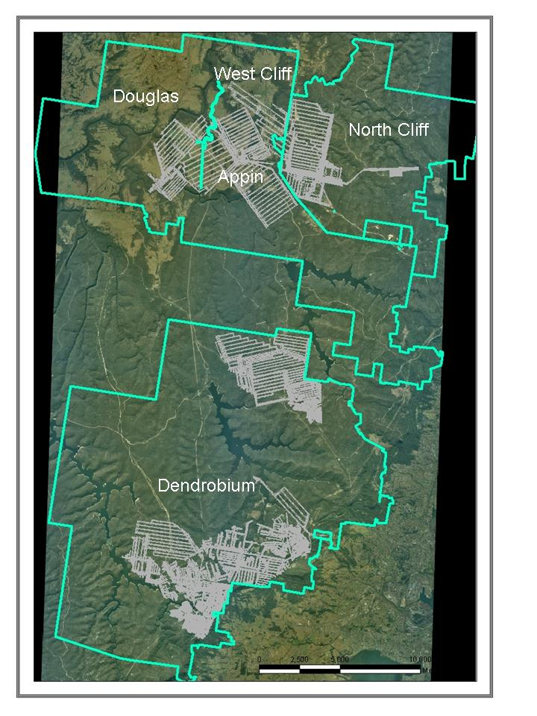
Fig. 1 - Location of Illawarra Coal operations

In similar fashion specialist techniques are required for the collection and analysis of strata oil. Assessment of these liquid hydrocarbons is required to ensure that, as a result of the ingress of any liquids into the goaf or workings, there are no adverse impacts on mining operations or personnel.

The mines are overlain by an interbedded sequence of sandstones mudstones, claystones and shales of the Triassic Narrabeen Group, Hawkesbury Sandstone and the Wianamatta Group. The principal reservoirs for strata oil and gas are the Coal Cliff, Scarborough and Bulgo Sandstone Formation (refer to Figure 2).

Fig. 2 - Stratigraphy of the Southern Coalfield
DOWNHOLE GEOPHYSICAL LOGS
The techniques of geophysical logging and log analysis are mainly applied in the petroleum industry for geological purposes and reservoir evaluation. The variant of this used in mining applications is known as slimline logging and involves a less comprehensive suite of tools. The tools typically run by BHP Billiton are:

- natural gamma ray log,
- density log,
- sonic log,
- cement bond (full waveform sonic) log
- neutron porosity log,
- caliper log,
- resistivity log (laterolog),
- temperature log,
- borehole survey log,
- acoustic scanner.

From the density log it is possible to determine basic lithological information on the coal seams and their ash content; the sonic log gives information on rock strength; stress directions and fracturing information are derived from the acoustic scanner; porosities come from the density and neutron logs; and shaliness (clay content) is derived from the gamma and neutron/density logs. Descriptions on how these parameters can be derived is found in textbooks such as Rider (1995) and Hearst et al (2000). Hatherly et al (2004) also developed the methodology for use in the coal fields of the Sydney and Bowen Basins. It is this approach that has been utilised in the present work.
The presence of gas within rock pores can also be inferred from the porosities derived from density and neutron logs. This is a straightforward procedure but it is qualitative in nature.

From the density log, rock porosity is determined by comparing the measured density with an assumed density for the solid components of the rock. The difference between these is attributed to the amount of pore space present which is assumed to be water saturated. It therefore follows that if the pores contain gas as well as water, then the observed density will be lower than for the water saturated case and the inferred porosity is larger.

In the case of neutron logging, this log mainly responds to the amount of hydrogen present in the rock formation. In clastic rocks, hydrogen is mostly present in water – either in the free water within the rock pores or within the bound water associated with clay minerals. Because of the presence of bound water, a neutron log calibrated to give an accurate porosity in a clean quartz sandstone will usually suggest higher than actual porosities.

In clastic rocks, the porosity indicated by neutron logging is therefore typically greater than the porosity derived from density logging. However, when gas is present in the rock pores, the neutron log will not be responding to as much hydrogen as it would if the pores were fully water saturated. The indicated porosity is therefore lower – typically lower than the porosity from the density log, especially if the density log is suggesting higher porosities due to the reduced water saturation.

When the neutron porosity is lower than the density porosity, a porosity cross-over is said to occur. The inference is that gas is present within the pores. In the case of the porosity logs from the Appin area, many of the sandstone units, most notably the Scarborough Sandstone, the Bulgo Sandstone and the Hawkesbury Sandstone are found to contain porosity cross-overs. A typical result for the Scarborough Sandstone is shown in Figure 3. Interpreted porosity is shown in blue and shale content in maroon.

Such analysis can only be used as a guide to the presence of gas. However, supportive results can be obtained from an analysis of resistivity logs and liquid hydrocarbons because these can be resistive zones within the geological section. As well, reports of gas make are often made while drilling the holes where gas cross-overs occur. In other Australian coal mining districts where strata gas is not present, the geophysical logs do not show the same behaviour in the porosity logs.
GAS INDICATIONS FROM DOWNHOLE GEOPHYSICAL LOGS
Geophysical logs from approximately 70 exploration boreholes in the Appin, West Cliff and Douglas areas have been studied to show strata characteristics and gas cross-overs. A comprehensive strata gas model is still under development but preliminary observations are as follows:
Scarborough Sandstone
This unit is 20-30 m thick and lies approximately 50 m above the Bulli Seam. The cumulative thickness of the gassy intervals may be up to 4 m, even when requiring a conservative difference of -0.5 % between the density porosity and the neutron porosity to be the threshold for a porosity crossover. Results contoured across this area are shown in Figure 4. It is notable that the thickness of the gas intervals decrease to the east where the underlying Wombarra Claystone is uniform and presumably is an effective seal. Over most of the area, there is approximately 1 m of cumulative gas, increasing to over 4 m in the north-western region where the geophysical log interpretation shows the Wombarra Claystone to be more sandy and more porous.
Bulgo Sandstone
This unit is approximately 150 m thick and can contain numerous intervals with porosity cross-overs. As shown in Figure 5, the cumulative thickness of the gassy sections is up to 20 m. (It reaches 30 m in boreholes S1780 and S1781 which are located on a sharp hill with 60 m local relief). There is also a tendency for the gassy sections to become more prevalent towards the top of the Bulgo Sandstone. This is consistent with the increase in porosity and sandiness within the Bulgo Sandstone that is observed from the geophysical log analysis and the notion that the overlying Bald Hill Claystone is an effective seal. However, understanding of the more detailed stratigraphic controls on the occurrence of the gas has still to be developed. The top of the Bulgo Sandstone is approximately 300 m from the Bulli seam and there is a reasonable expectation that the upper section of the formation will be isolated from the goaf.
Fig. 3 - Porosity cross-overs in the Scarborough Sandstone
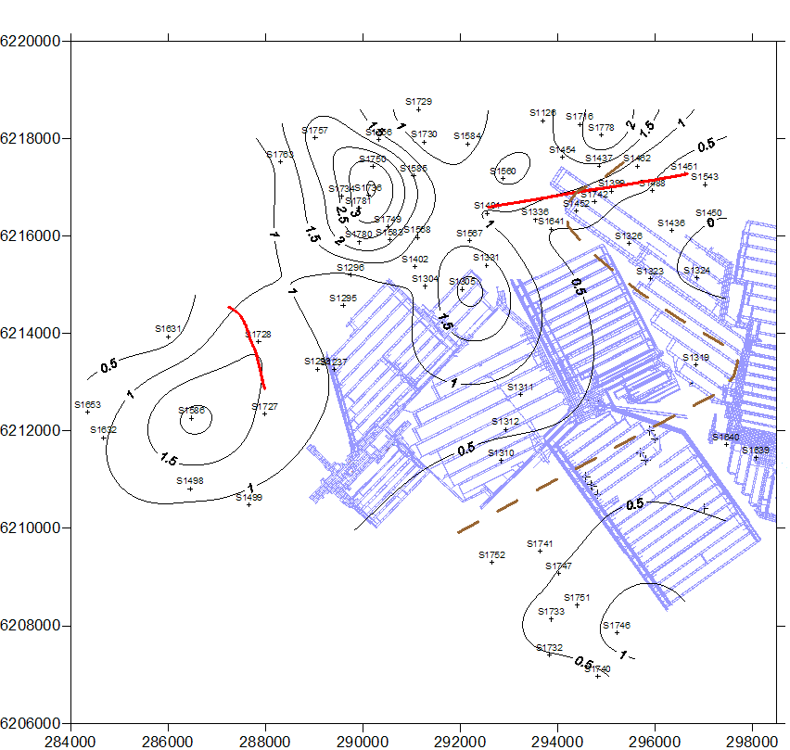

Fig. 4 - Cumulative thickness of gas intervals in the Scarborough Sandstone
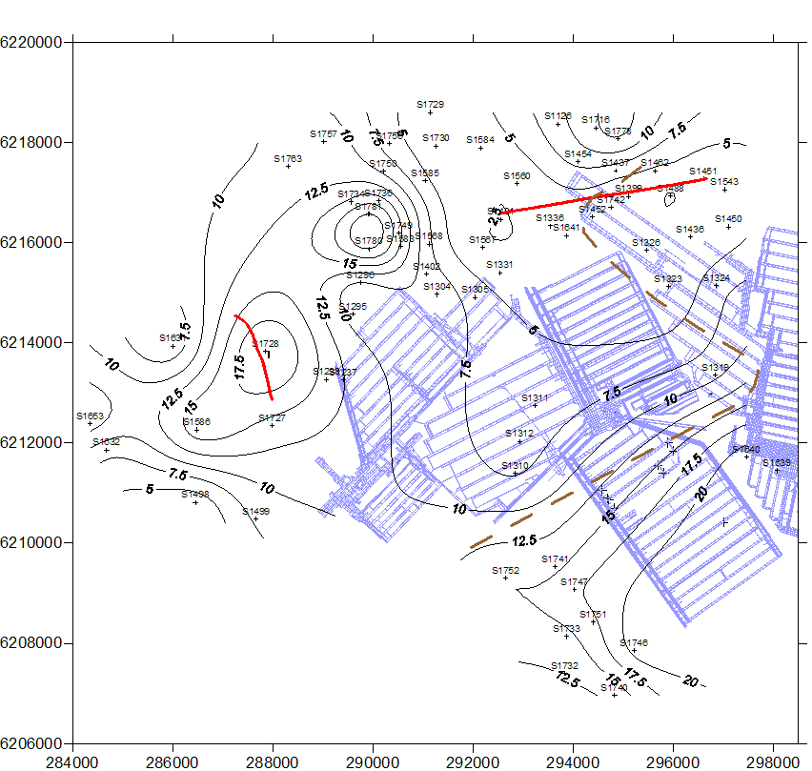

Fig. 5 - Cumulative thickness of gas intervals in the Bulgo Sandstone
Resistivity logs
Interpretations of resistivity logs for a number of holes in the Appin area was undertaken by Mr Roland Turner of Borehole Logging Consultancy Services (Hatherly and Thomson, 2006). The interpretations were aimed at detecting hydrocarbons (gas and fluids) in the Scarborough and Bulgo Sandstones. Care was exercised to choose appropriate values of the resistivity for the pore water and the resistivity of clay rich formations and in general terms, the resistivity interpretations showed that the zones with porosity cross-overs were also resistive and with water saturations of less than one. This is taken to be independent confirmation of the presence of strata gas in the Scarborough and Bulgo Sandstones.

GAS INDICATIONS FROM SEISMIC DATA
BHP Billiton makes extensive use of 2D and 3D seismic reflection surveying to allow the detailed mapping of coal seams and the structures affecting them which might impact on mining. Another aspect of the seismic data that is receiving increased attention concerns the changes to the quality of the seismic signals which pass through the ground. The seismic velocities, the signal amplitude and its frequency content can all indicate the physical properties of the medium through which the waves are travelling. Wave velocity is related to the modulus and hence the well known empirical relationships between velocity and UCS. Amplitude and frequency content are related to the rate at which seismic signals disperse and are absorbed by the ground. In particular, if the rock pores contain gas as well as fluids, then higher rates of absorption occur.

The full waveform sonic and acoustic scanner logs can also show the same effects due to gas in the formation. However, care is required in identifying the causative factors affecting the seismic signal. Variations in signal strength in the borehole sonic logs can also be caused by changes in rock type. Gas issuing into the borehole and mixing with the borehole fluids will also result in a significant loss of signal, even to the extent of no signal being detected at all. It is also a frequent observation that within about 200 m of the deep river gorges in this area, the seismic and sonic logging data are generally of poorer quality than elsewhere. Changes to the fold in the seismic data due to the inaccessibility for shot hole drill rigs and geological factors such as the lower water table and possible fracture systems, either pre-existing or induced by stress concentrations in the valley floors (Hebblewhite et al, 2000), are postulated to be the cause for these gorge effects.

An example of the effects of gas on seismic and full waveform sonic data is shown in Figure 6 (for locations see Figures 4 or 5). This seismic line is distant to the gorge systems and on the left (north) of the line there is a decline in the quality of the reflector from the Bulli Coal seam and the Scarborough Sandstone. Borehole S1728 is nearby and the results of the gas analysis for the Bulgo Sandstone in Figure 5 shows that the cumulative thickness of gas in the Bulgo Sandstone increases in this region. The decline in the quality of the seismic data is thought to be due to this.

Figure 6 also shows the relevant part of the full waveform sonic log and the geophysical log interpretation. In the Scarborough Sandstone at about 450 m depth, there is a reduction in the signal strength of the full waveform sonic log. This coincides with the inferred gas zone from the porosity log analysis. Further up the hole in the Bulgo Sandstone at 340 m - 350 m, a number of gas zones are indicated. Here the full waveform sonic log almost totally looses signal and the interpretation is that this is due to the flow of gas from the formation into the borehole.

Fig. 6 - Full waveform sonic log and seismic section illustrating signal disruption to strata gas

Figure 7 shows an example of the deterioration is seismic record quality that occurs when a seismic line approaches the gorge systems. For the left hand (western) half of this line, there is a marked reduction in the quality of the seismic data. The reflection from the Bulli Coal seam becomes irregular and the reflection from the Scarborough Sandstone is absent altogether. These effects are not interpreted to be due to changes in the nature of the reflectors. The interpretation is that these are due to the combined effects of the reduced seismic fold, the lower water table, stress and fracturing.

Fig. 7 - Disrupted seismic reflectors in the Scarborough Sandstone
OIL OCCURRENCES
Oil has been observed from drill core in the Narrabeen Group sandstone units overlying the Bulli seam. Minor oil occurrences have been observed in the 200 m interval above the seam within the Bulgo, Scarborough and Coal Cliff Sandstones. These formations consist of mainly of fine- to medium-grained lithic sandstones with minor pebbly conglomerates. Oil occurs predominantly in the coarser units. These formations consist of stacked alluvial channel sequences which are both laterally and vertically discontinuous. This provides an explanation as to why the oil is not restricted to specific mappable horizons. The reservoir appears to be confined to the Douglas Park Syncline.

Analysis of the oil indicates that it is terrestrial in origin and, most likely, originated from the adjacent coal seams and carbonaceous units.

Currently the oil is detected by visual observations of exploration borecore and drilling water sumps. A ultra-violet detector is also routinely used to detect the presence of hydrocarbons.

Samples within the strain relaxation envelope of longwall mining are subjected to chemical analysis to ensure that they do not contain hydrocarbons that are detrimental to the health of mine workers. Work to date indicates that the strata does not contain compounds which will impact on future operations. It is important to note that oil has only been observed in very small quantities and over short stratigraphic intervals.D
DISCUSSION AND IMPLICATIONS FOR MINING
Faiz et al (2003) describe a model for the generation of coal seam and strata gas in the Illawarra region. It entails the following processes.

- The generation of primary biogenic methane through the initial decomposition of plant material followed by the generation of thermogenic gases through normal coalification. These processes led to the development of mainly methane and minor amounts of CO₂ and “wet’ gasses such as ethane. The thermogenic processes continued from the Permian period (250 million years ago) through to the Late Cretaceous period some 90 million years before the present.

- Subsequent extension, uplift and erosion associated with the rifting of the Tasman Sea continuing through to the Early Tertiary period 50 million years ago. Large amounts of thermogenic gas were lost during this time however igneous activity, partly in association with the uplift and rifting events, simultaneously introduced CO₂ to the region. Because the uplift, erosion and extension also allowed the influx of meteoric water through open fracture systems, microbial agents were conveyed to the coal measures. These have subsequently acted on the CO₂ to produce secondary biogenic methane in significant quantities.

- A present situation whereby the Illawarra region is under compression and only coals at depths greater than 700 m tending to contain thermogenic methane. The shallower coals contain mainly secondary biogenic methane and some CO₂ in areas where biogenic agents have not been introduced presumably on account of local variations in permeability. These areas also need to be shallower than about 600 m - 700 m because CO₂ is highly soluble at greater depths. In the areas where biogenic methane is present, higher gas saturation levels are typically encountered.

With such a geological history, it is evident that gases have had many opportunities to migrate into the strata overlying the coal seams. The existence of permeable pathways at some stage is an evident requirement but these pathways could be due to the intrinsic permeability of the sediments as well as via faults, dykes and fracture systems. The fracture systems might be those that allowed the escape of thermogenic gases from the coal and the introduction of the microbial agents, as well as those due to current stress effects around the gorges and due to mining itself. For the older pathways, it is quite possible that the development of the present dominant compressive stress field and diagenic processes have reduced the permeability of these zones.

In the absence of a clear model of gas migration into the overlying strata, the best strategy for understanding the occurrence of strata gas is to attempt to map it from the geophysical wireline logs. However the mapping becomes difficult if drillholes post-date mining induced changes to the gas contents (e.g. S1742). The correlation between the high levels of gas in the north west (particularly in boreholes S1780 and S1781) and an abrupt 60 m hill with associated capping of Wianamatta Shale is also intriguing but currently without explanation.

The converse, i.e. the flow of strata gas back into mine workings requires careful consideration. With a limited gas reservoir in the Scarborough Sandstone and a much larger reservoir in the Bulgo Sandstone, the important geotechnical questions is the proportion of these sources of gas that can be introduced to the mines via the fracture systems associated with longwall mining.

CONCLUSIONS
The use of downhole geophysical logs has provided a useful tool in identifying strata gas horizons.

Although downhole geophysical logs and seismic profiles can be used to determine the stratigraphic position and areal extent of the strata gas horizons, the following information is also required to determine the potential increase on mine gas emissions:

- Reservoir pressure
- The extent of mining-induced permeability subsequent to goaf formation
- The extent of fracture connectivity between the goaf and the gas reservoirs

There is a recognition that the discontinuous nature of the gas reservoirs and the localised and qualitative nature of the data-sets reduces the ability to accurately quantify the size of the reservoir.

Additional work is continuing to more accurately determine the extent of the overlying strata relaxation envelope in order to determine the extent of the connection between the gas-bearing horizons and the goaf. A related study to determine the fingerprint the gas composition in order to determine its stratigraphic origin is also on-going.
ACKNOWLEDGEMENTS
The valuable contribution to this study of Roland Turner of Borehole Logging Consultancy Services is acknowledged.
REFERENCES
Faiz, M, 2004. Microbial influences in coal seam gas reservoirs - review. Bac-Min Conference, Bendigo. 8-10 November 2004.
Faiz, M, Stalker, L, Sherwood, N, Saghafi, A, Wold, M, Barclay, S, Choudhury, J, Barker, W and Wang, I, 2003. Bio-Enhancement of Coal Bed Methane Resources in the Southern Sydney Basin, APEA Journal, pp. 595-610.
Hatherly, P, Sliwa, R, Turner, R and Medhurst, T, 2004. Quantitative Geophysical Log Interpretation for Rock Mass Characterisation. Final report to Australian Coal Association Research Program (ACARP), project C11037 (unpublished).
Hatherly, P and Thomson, S, 2006. Distribution of Strata Gas, Appin Area 3. Report to BHP Illawarra Coal (unpublished).
Hearst, J R, Nelson, P H and Paillett, F L, 2000. Well Logging for Physical Properties. John Wiley and Sons, 2nd edition.
Hebblewhite, B, Waddington, A and Wood, J, 2000. Regional horizontal surface displacements due to mining beneath severe surface topography. 19th Intl Conference on Ground Control in Mining, Morgantown, West Virginia, August 2000, pp. 149-157.
Rider, M, 1995. The Geological Interpretation of Well Logs. Whittles Publishing. 2nd edition.

BHP Billiton Illawarra Coal
CRC Mining Geophysics, The University of Sydney
Coalbed Concepts Pty Ltd

